A Report on a PCA-Assisted Logistic Regression Model for Accurate Breast Cancer Classification.

Introduction
This project focuses on predicting breast cancer using machine learning techniques. The dataset contains clinical and biological features that help distinguish between benign and malignant tumors. To enhance model performance, Principal Component Analysis (PCA) is applied for feature selection and dimensionality reduction. Various machine learning models are then trained and evaluated to identify the most accurate approach for early breast cancer detection.

Data Description

The dataset used in this project is a breast cancer dataset that contains diagnostic information for tumor classification. Each observation represents a patient’s tumor sample, with a set of features derived from medical imaging/biopsy analysis.
- Number of Instances (rows): 569
- Number of Features (columns): 33

Key Variables
- ID/Identifiers
  - id → Unique identifier for each patient/sample.
- Target Variable
  - diagnosis → Tumor type: M (Malignant) or B (Benign).
- Predictor Variables (Features)
  - Numerical measurements of tumor cell nuclei obtained from medical images.
  - Features typically include:
    - Radius (mean of distances from center to perimeter)
    - Texture (variation in gray-scale values)
    - Perimeter
    - Area
    - Smoothness (local variation in radius lengths)
    - Compactness (perimeter² / area − 1.0)
    - Concavity (severity of concave portions of contour)
    - Concave Points (number of concave portions)
    - Symmetry
    - Fractal Dimension
Each of these features is calculated for mean, standard error, and worst (largest value), leading to a total of about 30 numerical attributes.
Data Analysis
To enhance the efficiency and predictive accuracy of the subsequent machine learning models, Principal Component Analysis (PCA) was employed for dimensionality reduction and feature selection. The initial dataset comprised 30 numerical features, a substantial number of which exhibit significant multicollinearity, as detailed in the correlation matrix (Figure 1).
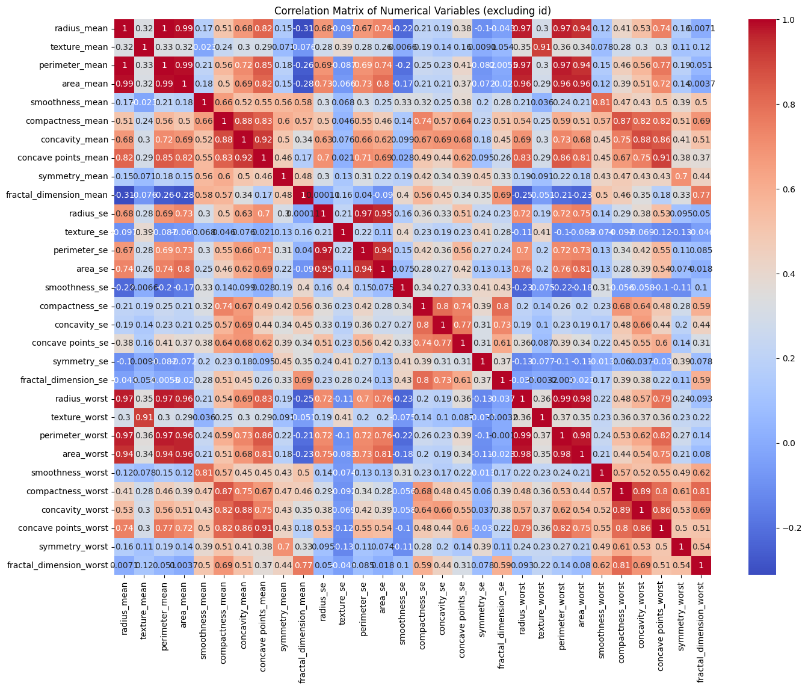
Figure 1

High correlation among predictor variables introduces redundancy, meaning the same information is represented by multiple features. This redundancy can inflate the computational complexity of model training and, in some cases, lead to instability in model parameter estimates (a phenomenon known as multicollinearity). For instance, the correlation matrix reveals near-perfect positive correlations (e.g., radius_mean with perimeter_mean at r ≈ 0.99), indicating that these variables convey almost identical information.

Applying PCA
Standardization
Prior to applying PCA, the data was standardized. This critical preprocessing step transforms all features to a common scale with a mean of zero and a standard deviation of one, using the formula:
z = (x - μ) / σ
where x is the original value, μ is the feature's mean, and σ is its standard deviation.
Eigen Value
Principle component | Eigen value | Explained Variance
PC1 | 13.31145 | 0.428647
PC2 | 5.706835 | 0.183768
PC3 | 2.840387 | 0.091464
PC4 | 1.984845 | 0.063915

From this table , The first principal component (PC1) is by far the most significant, capturing 44.3% of the total information. This component represents the single largest, most dominant pattern or trend present in the data.
Following this, the second principal component (PC2), which is entirely independent of the first, accounts for an additional 19.3% of the variance. By combining just these first two components, we can effectively create a two-dimensional representation of the data that successfully retains 63.6% of the original information.
The third principal component (PC3) captures a smaller, more nuanced pattern, explaining the next 8.0% of the variance. In total, all three components together explain 71.6% of the dataset's total variability.
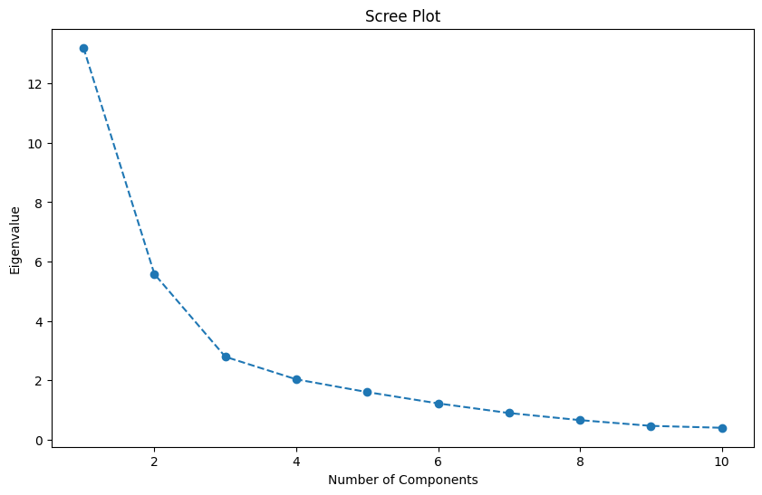
The scree plot visually confirms that the first few components are the most dominant. The sharp drop-off in eigenvalues after Component 3 suggests that a 3-component model would be an efficient and parsimonious choice, capturing the most significant variance while discarding the "noise" represented by the subsequent components.
Eigen loading
Table 1, Complete Eigenvector Loadings for PC1, PC2, and PC3 This table details the complete loadings for all original features. A positive value means the feature and the component move in the same direction, while a negative value means they move in opposite directions.
variable | PC1 | PC2 | PC3
radius_mean | -0.21891 | -0.23327 | 0.011394
texture_mean | -0.10384 | -0.06004 | -0.06689
perimeter_mean | -0.22754 | -0.21459 | 0.012125
area_mean | -0.22105 | -0.23067 | -0.02629
smoothness_mean | -0.14242 | 0.186422 | 0.103182
compactness_mean | -0.23907 | 0.152455 | 0.074769
concavity_mean | -0.25828 | 0.060542 | -0.00176
concave points_mean | -0.26074 | -0.03417 | 0.02758
symmetry_mean | -0.13798 | 0.190685 | 0.040962
fractal_dimension_mean | -0.06415 | 0.366531 | 0.020818
radius_se | -0.20612 | -0.10594 | -0.26692
texture_se | -0.01741 | 0.089548 | -0.37144
perimeter_se | -0.21145 | -0.08981 | -0.26493
area_se | -0.20308 | -0.15277 | -0.21579
smoothness_se | -0.01468 | 0.20319 | -0.31179
compactness_se | -0.17029 | 0.232503 | -0.15456
concavity_se | -0.15354 | 0.196846 | -0.17656
concave points_se | -0.18341 | 0.129965 | -0.22385
symmetry_se | -0.04242 | 0.183559 | -0.28527
fractal_dimension_se | -0.1025 | 0.279584 | -0.21189
radius_worst | -0.22801 | -0.2193 | 0.049406
texture_worst | -0.10452 | -0.0455 | 0.039829
perimeter_worst | -0.23664 | -0.1993 | 0.050432
area_worst | -0.22493 | -0.21899 | 0.013189
smoothness_worst | -0.12782 | 0.172563 | 0.255329
compactness_worst | -0.20989 | 0.144254 | 0.234514
concavity_worst | -0.2286 | 0.098527 | 0.172025
concave points_worst | -0.25075 | -0.00753 | 0.170481
symmetry_worst | -0.12268 | 0.142619 | 0.270516
fractal_dimension_worst | -0.13156 | 0.275702 | 0.229474
Table 1
The key features driving its variance were identified. This was achieved by ranking all features by the absolute magnitude of their loadings (coefficients). The magnitude indicates the strength of the contribution, regardless of its positive or negative sign.
Table 2 summarizes the top three most influential features for each component, as identified from the complete loading matrix in Table 1.

Important variable | PC1 | PC2 | PC3
fractal_dimension_worst | -0.131560 | 0.275702 | 0.229474
fractal_dimension_se | -0.102496 | 0.279584 | -0.211893
compactness_worst | -0.209885 | 0.144254 | 0.234514
radius_se | -0.206117 | -0.105936 | -0.266917
area_se | -0.203076 | -0.152771 | -0.215790
perimeter_se | -0.211447 | -0.089807 | -0.264926
compactness_se | -0.170288 | 0.232503 | -0.154557
smoothness_worst | -0.127824 | 0.172563 | 0.255329
concave points_se | -0.183407 | 0.129965 | -0.223850
symmetry_worst | -0.122680 | 0.142619 | 0.270516
fractal_dimension_worst | -0.131560 | 0.275702 | 0.229474
Table 2

Variable Selection and Coding
A set of ten diagnostic variables was selected from the dataset for use as predictors in the classification model. These variables represent key morphological and texture-related characteristics of the breast tumor, including:
- fractal_dimension_worst
- fractal_dimension_se
- compactness_worst
- radius_se
- area_se
- perimeter_se
- compactness_se
- smoothness_worst
- concave points_se
- symmetry_worst
The outcome variable was diagnosis, which originally contained two categorical values:
M (Malignant)
B (Benign)
To make the data suitable for machine learning algorithms, the diagnosis values were converted to numerical form:
M → 1
B → 0
After this transformation, the dataset consisted of 569 observations with 10 predictive variables and 1 binary outcome variable.

Training and Testing Split
To evaluate model performance objectively, the dataset was divided into training and testing subsets using an 80:20 ratio with a fixed random state (42) to ensure reproducibility. The resulting distribution of cases was:
Training data
  - 455 observations
  - 10 predictor variables
  - Corresponding binary target values
Testing data
  - 114 observations
  - 10 predictor variables
  - Corresponding binary target values
This approach ensures that the model is trained using the majority of the available samples while preserving a separate, unseen portion of the data to measure generalization performance and prevent overfitting.

Logistic Regression
Logistic Regression is a supervised classification method used to predict a binary outcome based on a set of independent variables. Instead of modeling the outcome directly, Logistic Regression models the probability of belonging to a particular class. For this purpose, it uses the logistic (sigmoid) function, which converts any real-valued input into a value between 0 and 1.
The logistic function is defined as:
$$P=\frac{1}{1+ⅇ^{-z}}$$

Where,
$$z=β_{0}+β_{1}x_{1}………+β_{n}x_{n}$$
Here,
- p predicted probability of the positive class (malignant),
- $x_{1}………x_{n}$ predictor variables,
- $β_{0}, β_{1}………β_{n}$ model coefficients estimated during training.
In Logistic Regression, the model converts the linear relationship into a log-odds scale using the following transformation:
$$\ln\left(\frac{p}{1-p}\right)=β_{0}+β_{1}x_{1}………+β_{n}x_{n}$$
The coefficients are estimated using maximum likelihood estimation (MLE), which finds the parameter values that maximize the probability of correctly predicting the observed outcomes.
In this study, Logistic Regression was applied to classify tumor samples as malignant (1) or benign (0). The model was implemented using the LogisticRegression class from scikit-learn in Python. A fixed random_state=42 was used to ensure reproducibility, and the liblinear (A solver is the algorithm used internally to find the best model parameters) solver was selected for stable convergence with binary classification problems. The model was trained on 455 observations, during which it estimated the coefficients $β_{0}, β_{1}………β_{n}$ that best separated malignant and benign cases.
Model Evaluation
Metric | Training Set | Testing Set
Accuracy | 0.91 | 0.95
These results demonstrate that the model achieved an accuracy of 91% on the training dataset and 95% on the testing dataset. The slightly higher accuracy on unseen test data indicates that the Logistic Regression model generalized well and did not exhibit signs of overfitting. This performance confirms that the chosen set of predictor variables and model parameters were appropriate and effective for accurately distinguishing between malignant and benign tumor samples.

Metric | Value
Accuracy | 0.9561
Precision | 0.9750
Recall | 0.9070
F1-Score | 0.9398

The performance evaluation of the Logistic Regression model showed strong predictive capability on the test dataset. The model achieved an overall accuracy of 95.61%, demonstrating reliable classification performance. A precision score of 0.9750 indicates that a very high proportion of the samples predicted as malignant were correctly identified. The recall score of 0.9070 reflects the model’s effectiveness in correctly detecting malignant cases, while the F1-score of 0.9398 represents a balanced trade-off between precision and recall.

Class | Precision | Recall | F1-Score | Support
0 (Benign) | 0.95 | 0.99 | 0.97 | 71
1 (Malignant) | 0.97 | 0.91 | 0.94 | 43
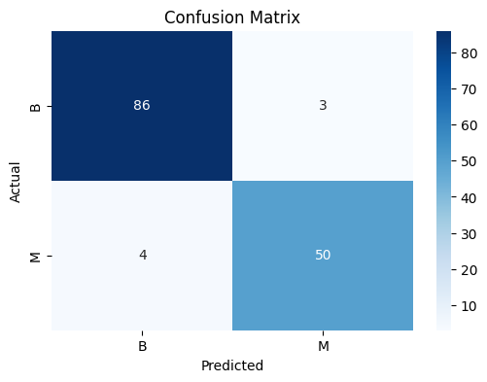
The detailed classification report shows that benign cases (class 0) were classified with a precision of 0.95, recall of 0.99, and F1-score of 0.97, based on 71 observations. Malignant cases (class 1) exhibited a precision of 0.97, recall of 0.91, and F1-score of 0.94 across 43 samples. These results indicate that the model performed consistently well for both classes, with particularly strong detection of benign cases and reliable identification of malignant tumors. A confusion matrix (figure 2) was also generated to visually illustrate the number of correctly and incorrectly classified benign and malignant cases.

Figure 2

Model Diagnostic Graphs
ROC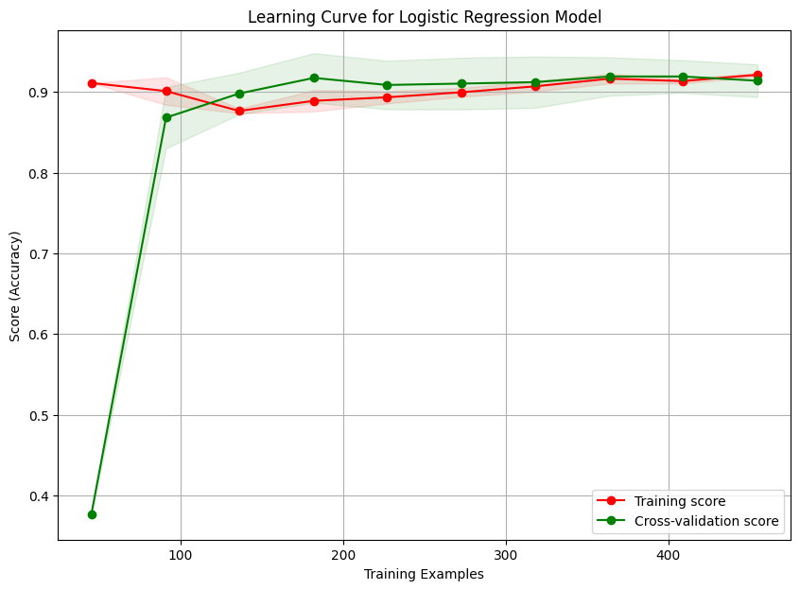

The learning curve shows how model accuracy changes with increasing training data size. The training accuracy starts high but stabilizes around 90–92% as the number of training samples increases. Likewise, the cross-validation accuracy increases sharply with more data and then settles close to the training score. The small gap between the two curves indicates that the model has good generalization capability and does not suffer from overfitting. The stable performance at higher sample sizes also suggests that adding more data may not significantly improve results, as the model has already reached performance saturation.
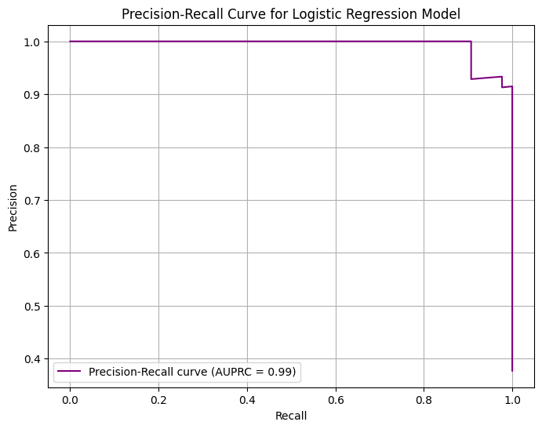
The precision–recall curve shows excellent model performance, with precision remaining very high across most recall levels. The AUPRC of 0.99 indicates that the logistic regression model effectively identifies positive cases while maintaining minimal false positives, making it highly suitable for imbalanced classification problems.
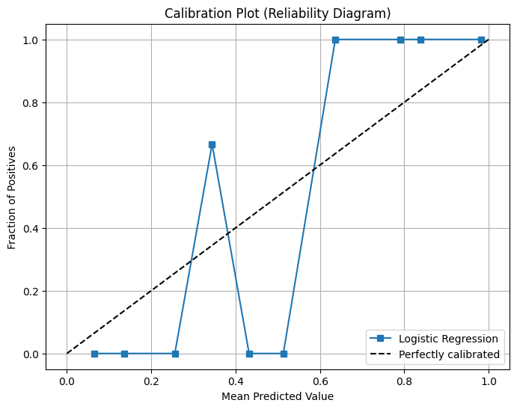

The calibration plot indicates that the logistic regression model is well calibrated at high predicted probabilities, where predictions closely match the observed outcomes. However, at low to mid probability ranges, the model shows some miscalibration, with predictions either overestimating or underestimating the true risk. Overall, the model provides reliable predictions for high-confidence cases, while probability estimates in the lower range could be improved with further calibration.
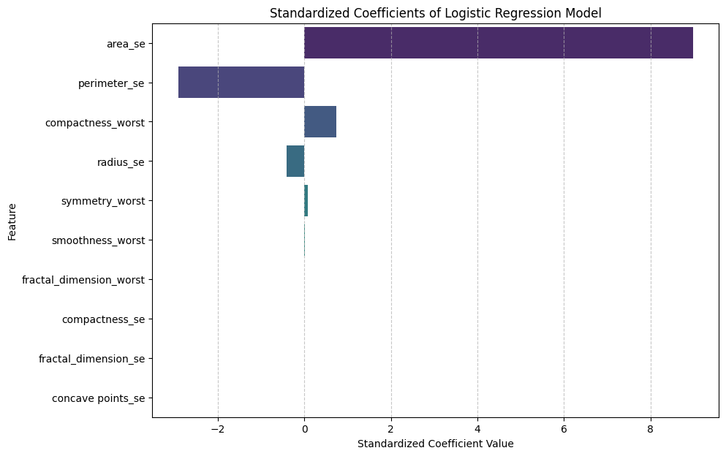

The standardized coefficient plot shows that area_se has the strongest positive influence on the model’s prediction, making it the most important predictor. Perimeter_se has a strong negative effect, indicating an inverse relationship with the outcome. Other features have relatively small coefficients, suggesting a weaker contribution to the classification compared to the dominant variables.
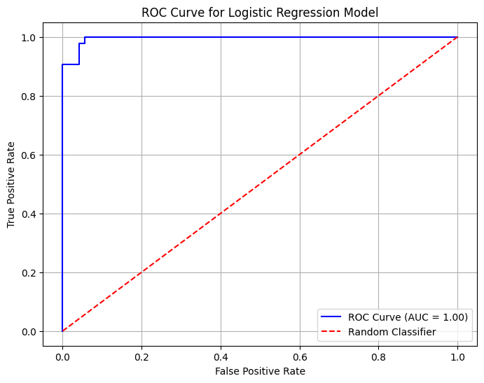
The Receiver Operating Characteristic (ROC) curve shows the trade-off between the True Positive Rate (Sensitivity) and the False Positive Rate at different classification thresholds. The curve in the graph lies close to the top-left corner, indicating excellent discriminatory power of the model. The Area Under the Curve (AUC) is approximately 1.00, which represents near-perfect classification performance. A diagonal red line is included in the plot to represent a random classifier, and the model’s curve being far above this reference line confirms that the Logistic Regression model performs significantly better than random guessing.
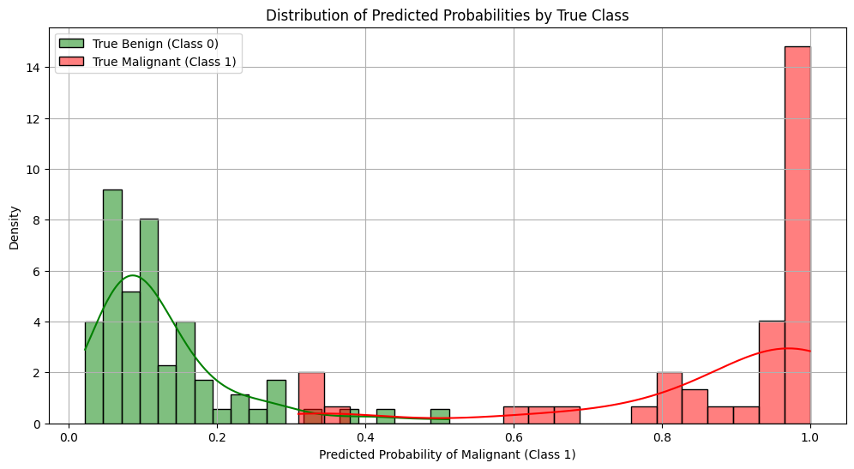

This graph shows the distribution of predicted probabilities for malignant (class 1) and benign (class 0) samples. The predictions for benign cases are concentrated near 0.0–0.2, while malignant cases cluster close to 0.8–1.0. The clear separation between the two distributions indicates that the model assigns high confidence to most predictions, demonstrating excellent class separability. The limited overlap between the two density curves shows that the model rarely confuses benign and malignant samples, further supporting the high precision and recall reported in the classification metrics.

